**Commodore VIC-20 Character ROM Adapter Rev. 0**

Test

# Test Setup

The Character ROM adapter Rev. 0 was electrically tested in two VIC-20:

1. A Vicky Twenty, which is a clone of ASSY250403 (the VIC-20 CR)
2. An original ASSY324003 (two prong VIC-20)

It was further mechanically tested in an original (non-functional) ASSY250403 with shield around the video circuit.

Finally, the adapter was reconfigured as a C64 adapter and tested with an

* ASSY250469 (short board)
* ASSY250425 (long board)

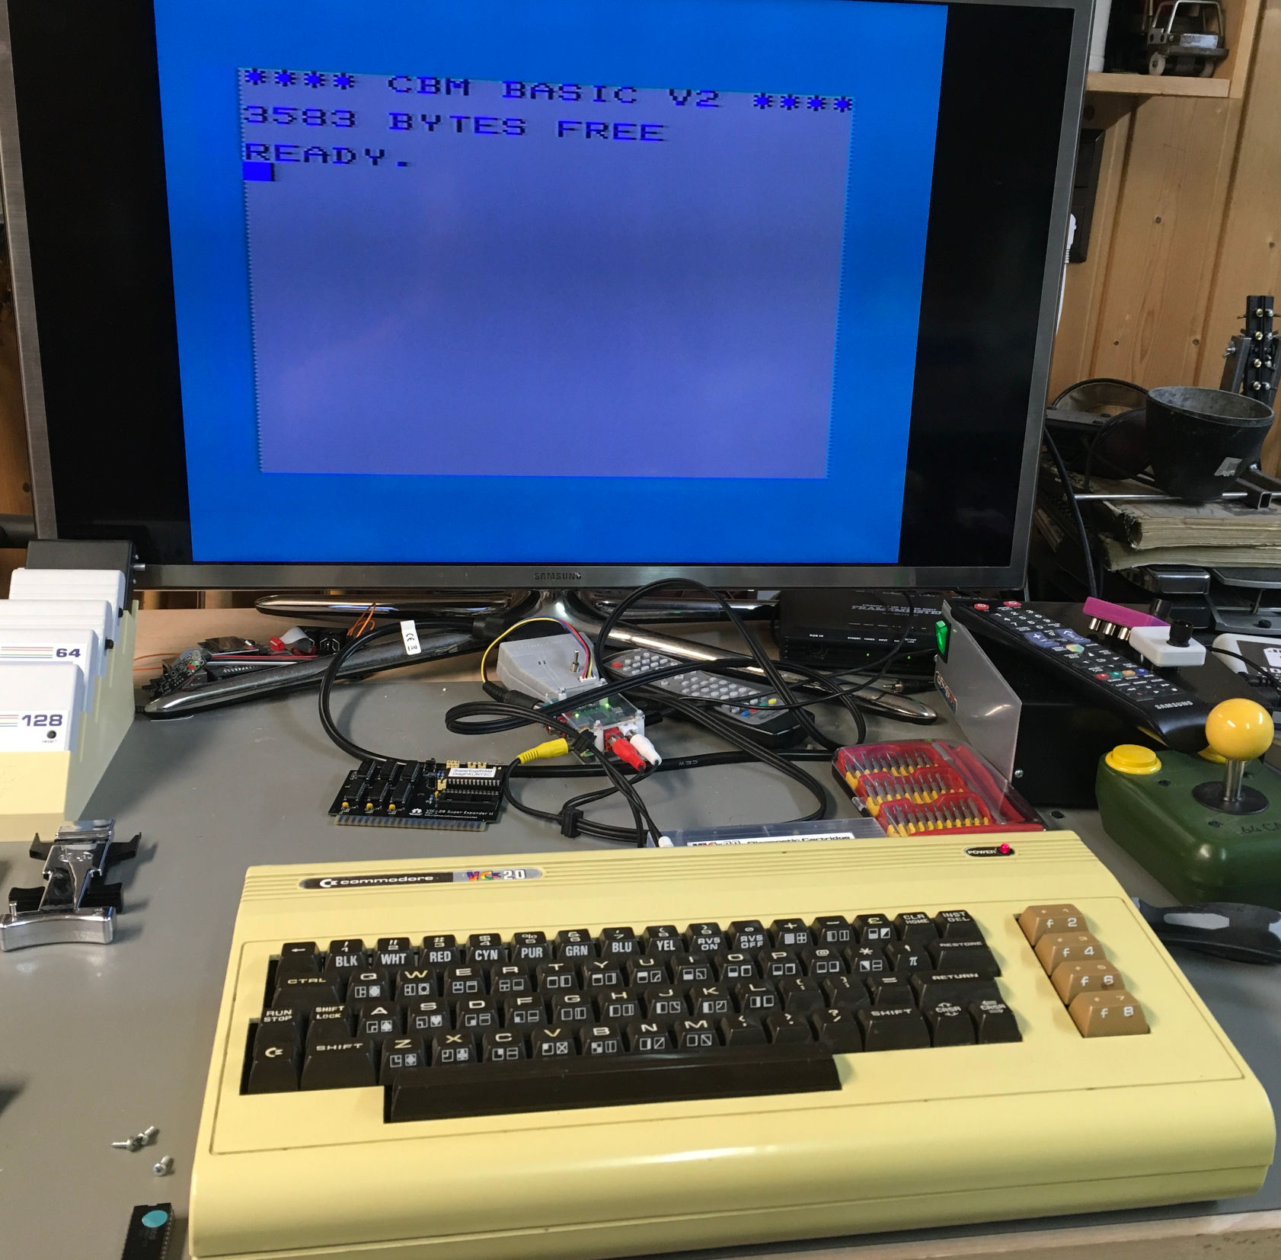

Figure 1: Test Setup with an ASSY324003 VIC-20

The screen shots were taken with a (cheap) CSL USB 2.0 Video Grabber.

# Test Execution

## Electrical testing

A ST 27C512 EPROM (120ns) was programmed with the original Commodore character sets:

* English/International
* Danish
* Swedish/Finnish
* VC-1001

Then installed in the Vicky Twenty. A test software was written, which puts all 256 characters on the screen.

The characters were displayed properly. Pulling/stetting jumpers resulted in switching character sets (the characteristic umlauts of the particular language became visible).  
The special Japanese characters became visible when switching to upper/lower case characters.

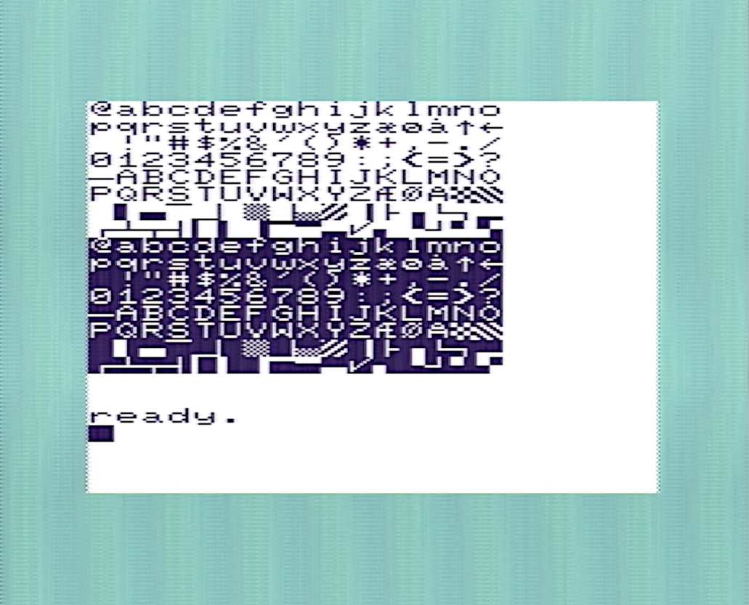

Figure 2: Danish character set on a VIC-20

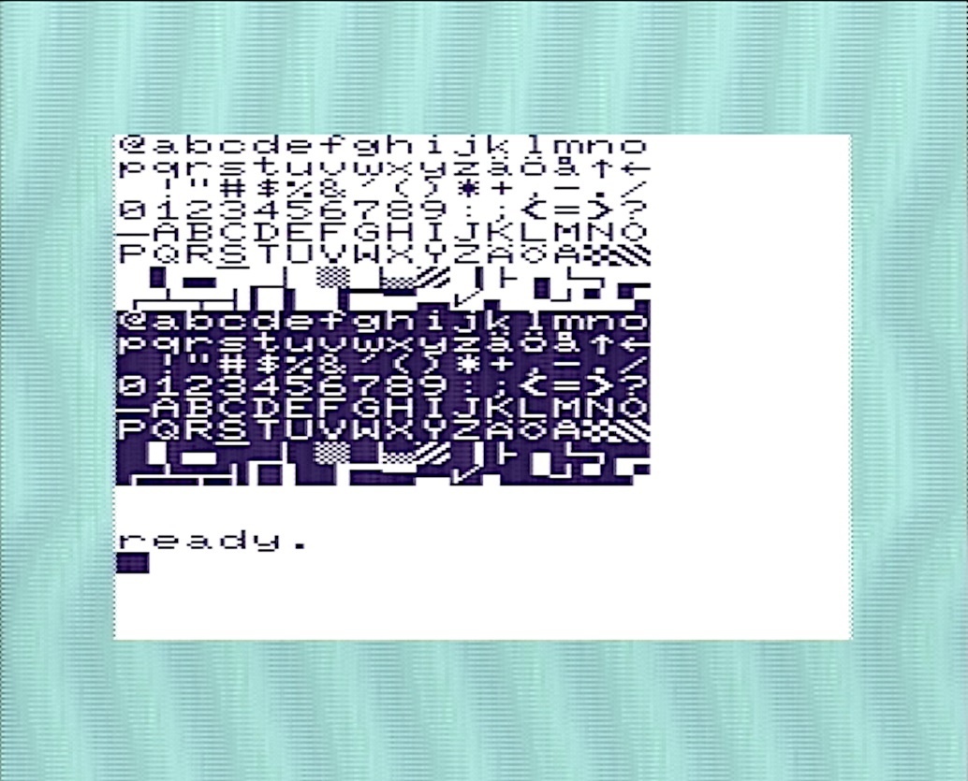

Figure 3: Swedish character set on the VIC-20

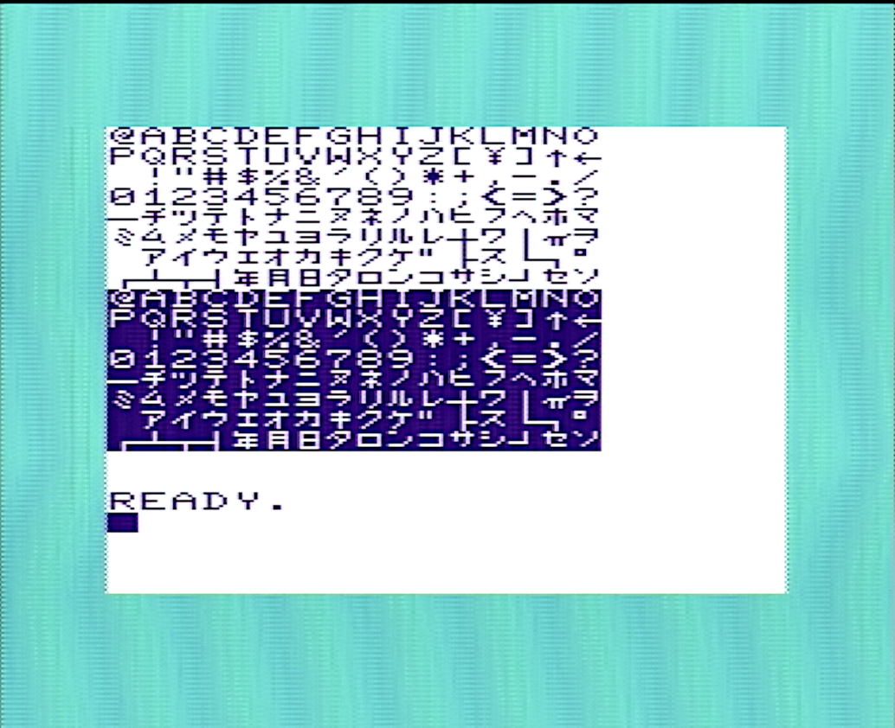

Figure 4: Japanese character set on a VIC-20

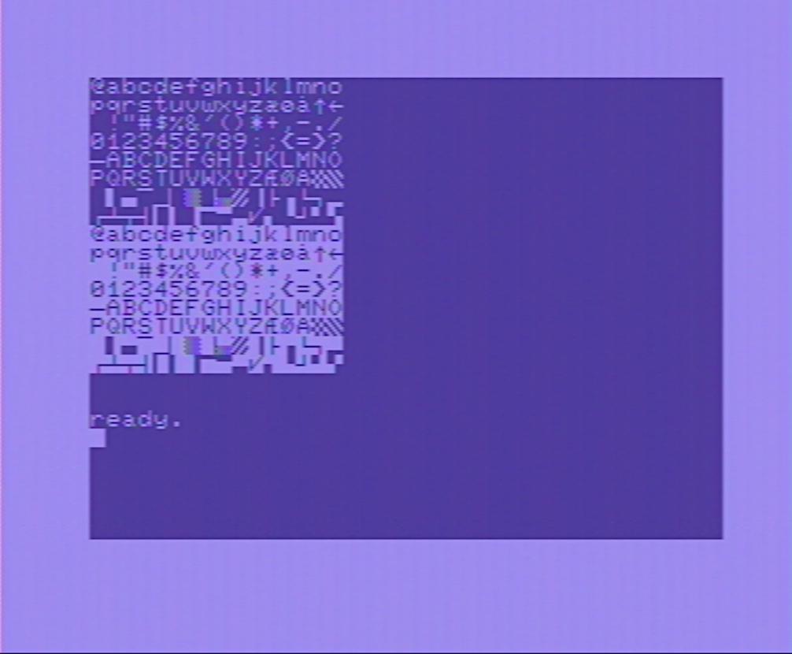

Figure 5: Danish character set on a C64

The character ROM adapter works in a VIC-20 when configured for this computer and works in a C64, when configures as a C64 adapter.

## Mechanical Testing

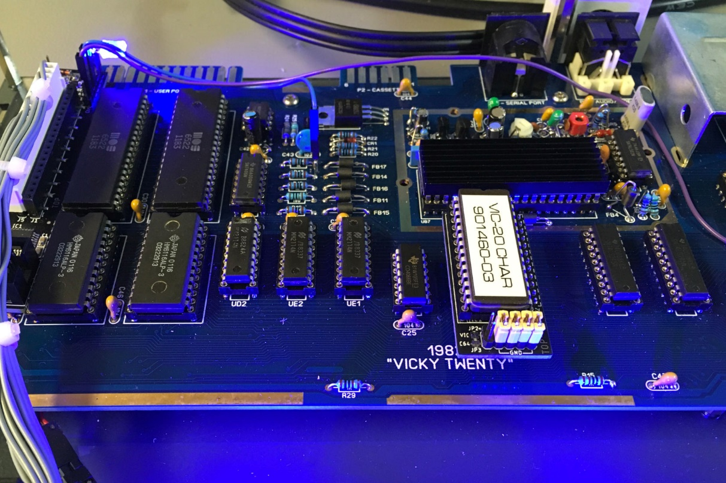

Figure 6: Character ROM Adapter in the VickyTwenty

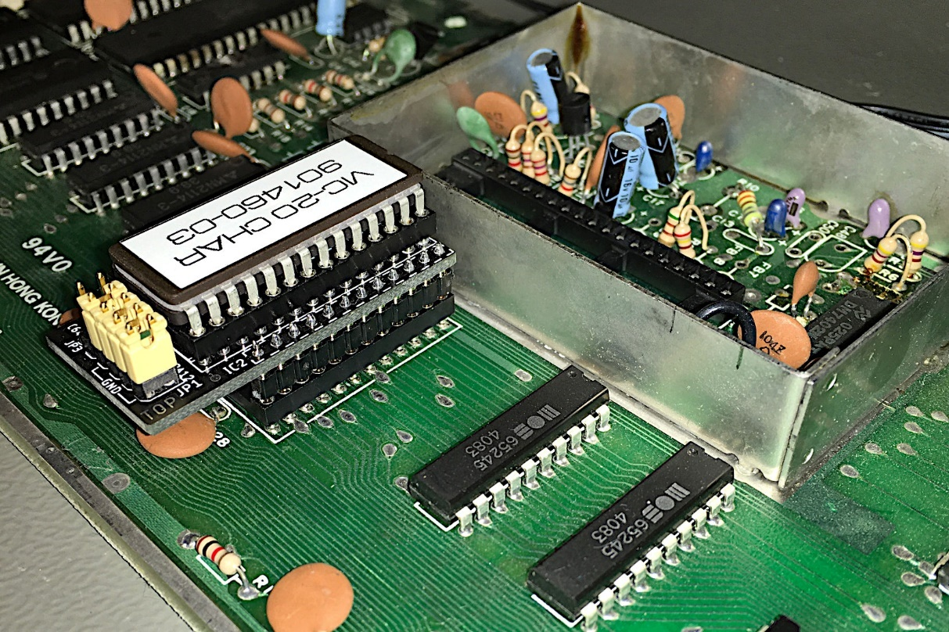

Figure : Character ROM Adapter in an ASSY 250403 (VIC-20 CR)

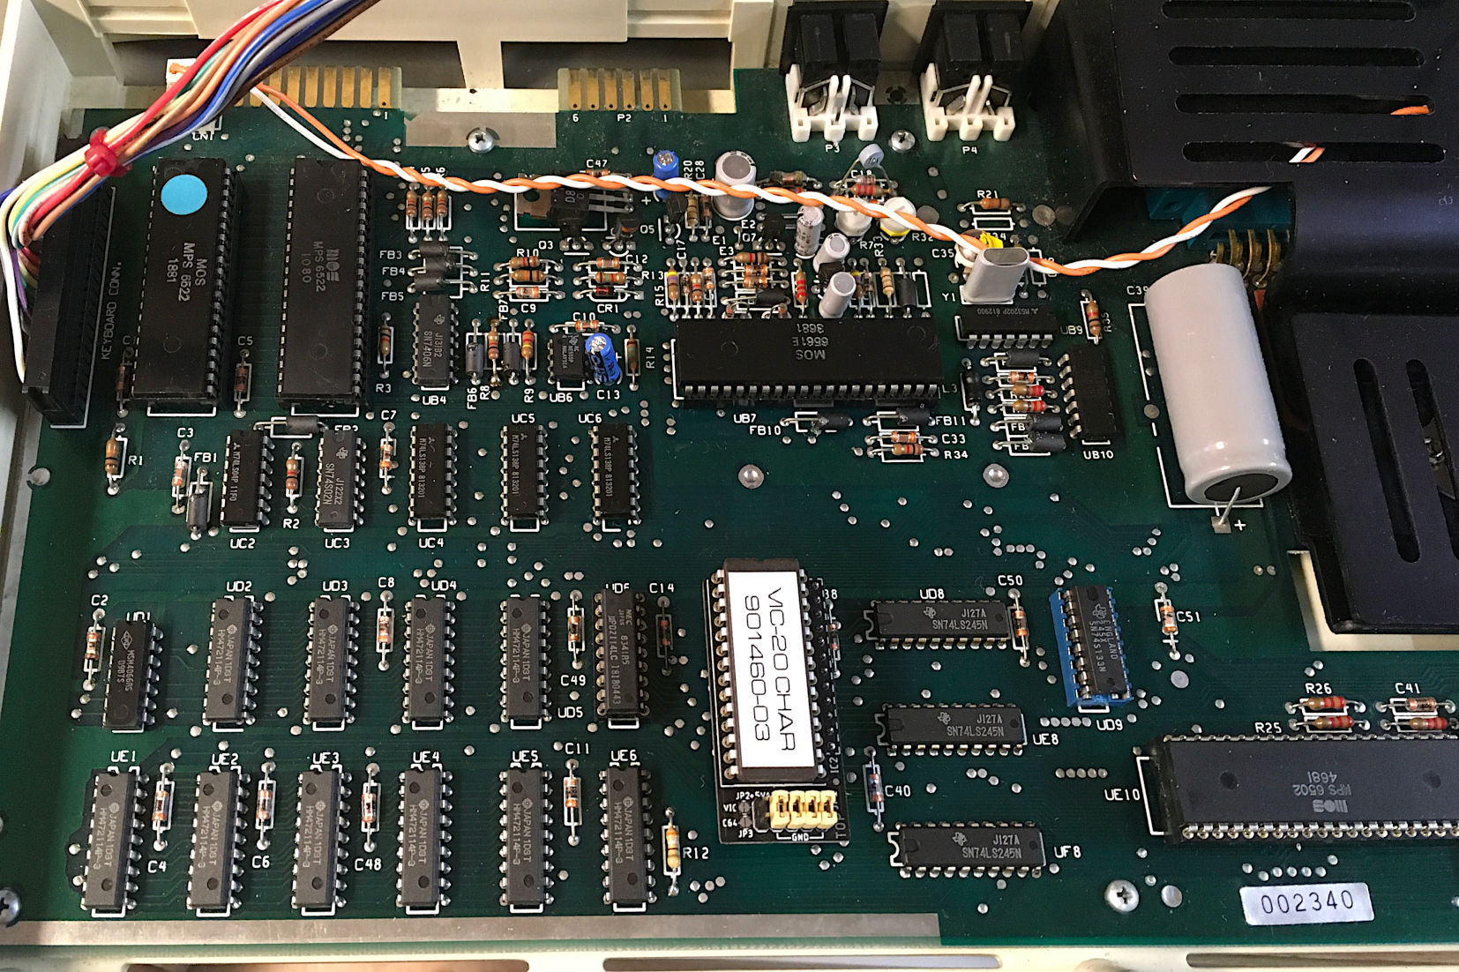

Figure 8: Character ROM Adapter in an ASSY 324003 (two-prong VIC-20)

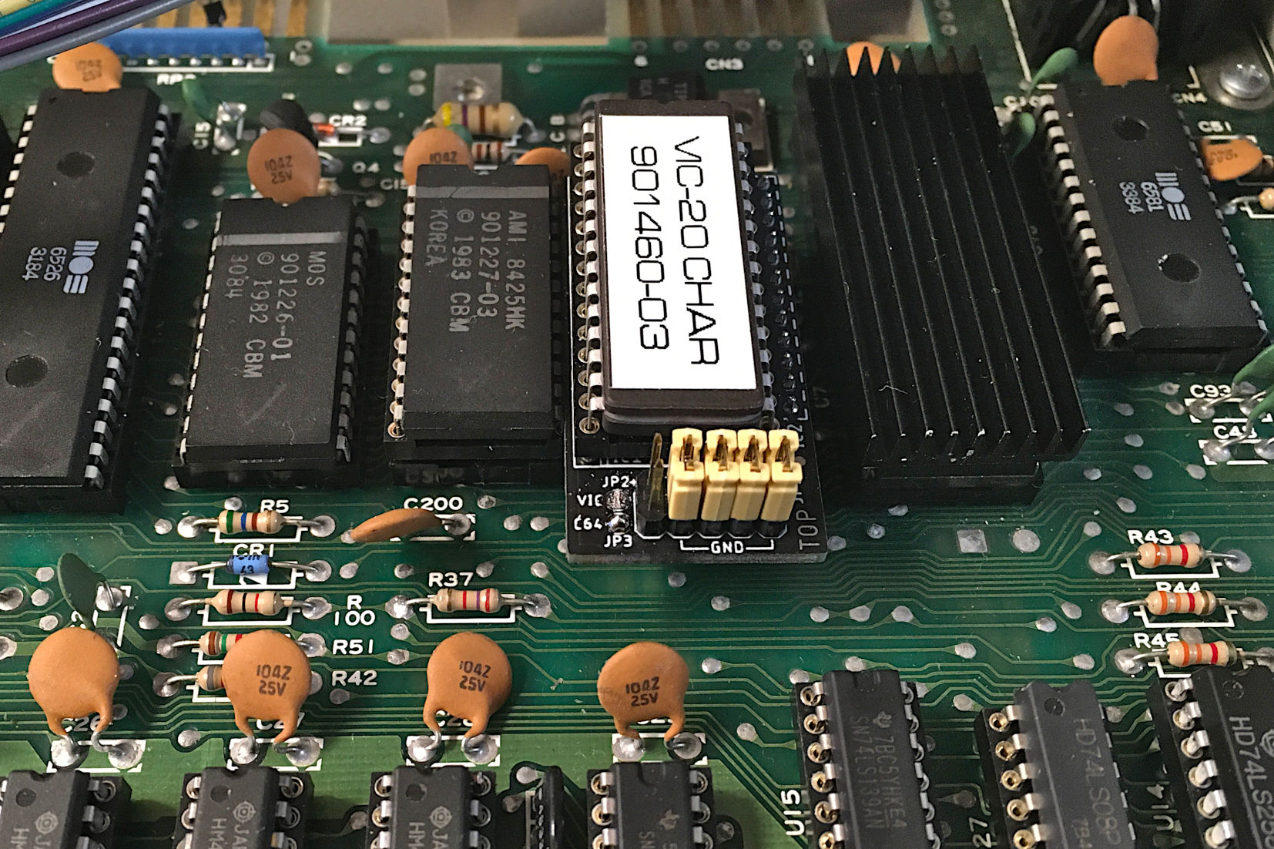

Figure 9: Test in the C64 ASSY 250425 (long board)

The VIC-20 Character ROM adapter fits in ASSY 250425 (and the other long boards). It would likely collide with a Kernal Adapter. Adding one or two precision round pin sockets might solve this problem.

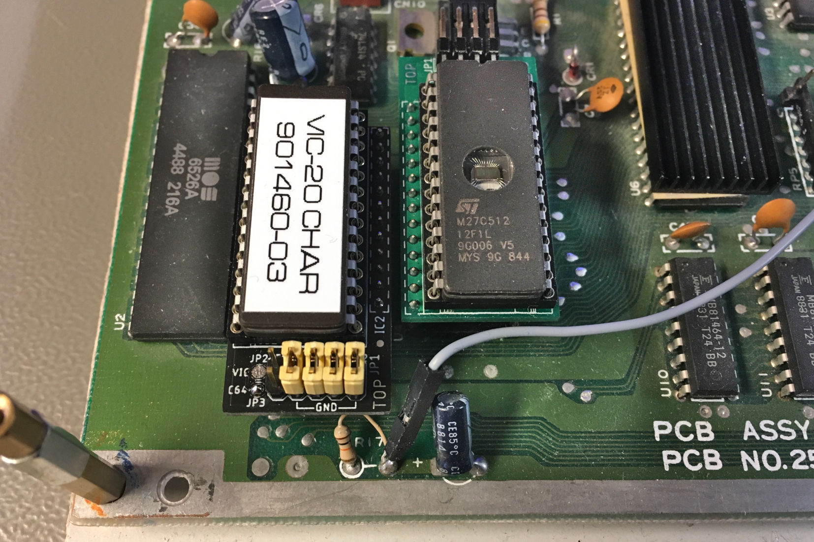

Figure 10: Test in a C64 ASSY250469 (short board)

# Conclusion

The VIC-20 Character ROM adapter Rev. 0 is fully functional in both the VIC-20 and the C64. For the C64 long boards, the dedicated character ROM adapter is recommended.